**The Demographic and Health Surveys Program (DHS)**

**CAPI CENTRAL OFFICE SYSTEM**

The DHS Program, ICF

Rockville, Maryland, USA

Table of Contents

1. Introduction 3

2. Analysis of Incoming data from the field 3

3. Accessing the Central Office Menu 5

4. Accepting cluster data coming from the field 7

5. Listing questionnaires for accepted clusters 10

6. Modifying household and individual questionnaires for a cluster 11

7. Viewing notes taken at the time of the interview for the cluster 13

8. Running secondary editing applications for the cluster 15

9. Producing a data collection status report for all clusters 17

10. Running check-field tables for the entire survey 20

10.1 How to use the tables 20

10.2 Reporting the findings from the field-check tables 21

10.3 Running the field-check tables 21

11. Closing a cluster 22

12. Moving among clusters 23

13. Backing-up the data 24

14. Exit (Esc) 25

# 1. Introduction

The purpose of the central office system is to centralize, monitor and carry out the post-processing of a DHS data collection operation. To properly accomplish this task, the system maintains a “Control Database” to keep track of the status for every cluster. The individual assigned to operate this system will be referred in this document as the “Administrator”. It is recommended that the person designated as Administrator is familiar with this type of fieldwork operation, s/he needs to be involved in the survey pretest and main training and should have ample familiarization with computers. The computer where the system is installed requires access to internet. Access to internet is required because the system uses the Internet File Streaming System (IFSS) to download the data being collected and transferred from the field by fieldwork supervisors.

To start the system, double click on the 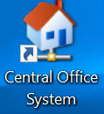 icon on the desktop designated for that purpose. The Central Office System is set-up in such a way that it first accesses the Internet File Streaming System (IFSS). The purpose for this step is to download to the central office desktop the data uploaded by supervisors in the field. The DHS data processing expert will provide the Administrator with a username and password to get access to IFSS.

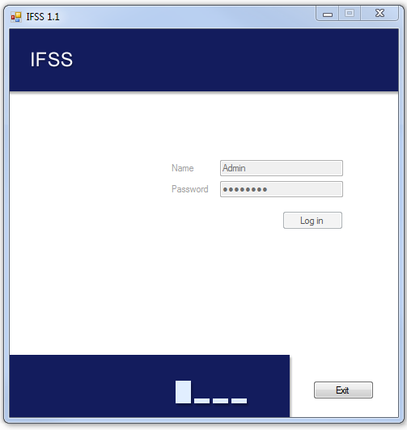

# 2. Analysis of Incoming data from the field

Upon sucessfully loging into the system and if internt is available, IFSS downloads to the designated central office desktop, the data being sent by supervisors from the field. As mentioned in the supervisor and interviewer manuals, supervisors centralize data from all team members in the field and sent that data to the central office via IFSS. The system is designed to upload to the IFSS server the files listed in the table below. The table provides a list of the typical files in a DHS survey operation that are uploaded by supervisors and downloaded in the central office. The column “**Origin - Supervisor**” indicates the directories where the files are stored in the supervisor tablet. The column “**Destination – Central Office**” lists the directory names where the data is downloaded in the central office desktop. Files coming from \Final and downloaded into \Arrived folders correspond to clusters sucessfully closed by supervisors. Files uploaded and downloaded into \Ref folder, are auxiliary files used by supervisors to keep track of each household in a cluster and to store transmittal sheets for biomarkers like HIV and malaria that require the use of barcodes. Files uploaded from \Receive and downloaded into \Work folders correspond to all files generated by interviwevers in each cluster. They are sent to central office for back-up purposes.

**Summary of data files Uploaded by Supervisors and Downloaded at the Central office**

|  |  |  |
| --- | --- | --- |
| **Origin - supervisor** | **Destination – Central office** | **Description** |
| \Final | \Arrived | Data files by cluster for households (HXXXX.dat), individuals (IXXXX.dat), other answers (OXXXX.dat), remeasurement (RXXXX.dat), notes (NXXXX.csnot) and paradata for clusters closed by supervisors in the field. Where XXXX is the cluster number |
| \Ref | \Ref | Supervisor Control (SupervXXXX.dat) and transmittal sheets files used by supervisor (TransmitYXXXX.dat). Where, XXXX is the supervisor code and Y is the type of transmital sheet (H-HIV, M-Malaria) |
| \Receive | \Work | All files generated by interviewers for households, individuals, other answers, notes, and paradata. |

After downloading the data, the central office system performs a series of checks and produces an HTML report with details of the downloaded files. The report is made out of two main components as can be seen in the figure below:

* The first part, “**Clusters that arrived to the central office for the first time**”. The clusters listed under the first part is for informative purposes and no action is required by the administrator. Some of these clusters may be final and some others are just starting the filedwork operation. If a cluster is final, it will also be included under the list in the second part of the report. This could happen when a supervisor was not connected to the internet for extended periods of time. By the time he was able to connect to internet, he had already closed some of those clusters. The system marks these clusters in the control database with the date when interviewers visit the cluster for the first time to start the data collection in the cluster. The system also updates the “Control Database”, with the code of the supervisor assigned to the cluster. These two pieces of information are displayed in the status report to be described later.
* The second part, “**Completed clusters to be accepted: 1-Arrived first time; 2-Already accepted; 3-Passed secondary editing**”, essentially describes clusters closed by supervisors in the field that need to be accepted by the administrator at the central office. There are three categories of them:
  + Arrived for the first time. These are completed clusters that arrived for the first time to the central. Clusters 0040 and 0046 fall under this category
  + Already accepted. These are clusters that arrived earlier and were accepted by the administrator. However, some modifications were made to the cluster in the field and as a result they were sent back again to the central office. Clusters 0044 and 0049 fall under this category
  + Passed secondary editing. These clusters arrivied earlier, were accepted by the Administrator, secondary editing was run and the cluster was declared closed for further processing by the Administrator. Since the cluster has to be accepted again, the secondary editing that was done to the cluster is lost and it is necessary to run that process again. Clusters 0038, 0045, and 0050 fall into this category

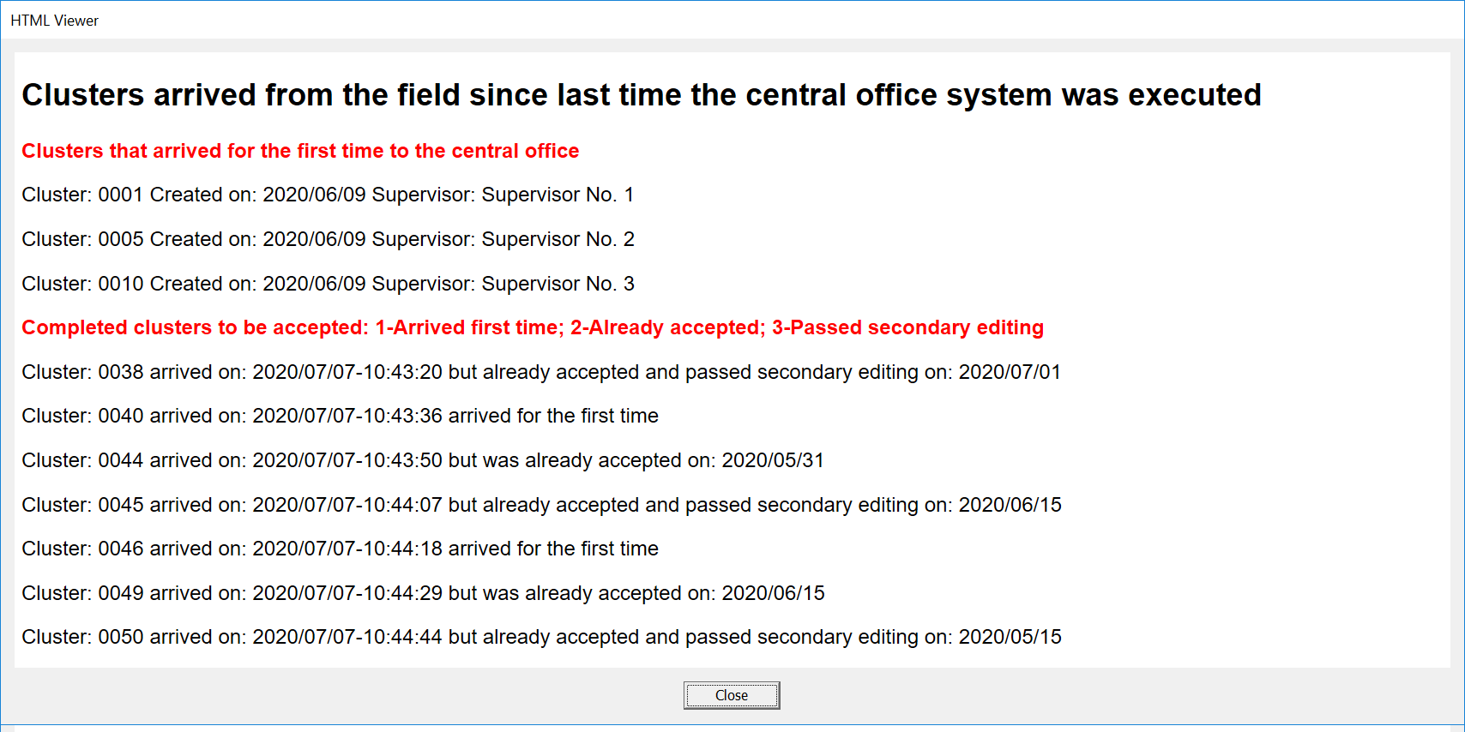

It is a good idea to print this report especially because the Administrator needs to accept all clusters listed as part of the second component and the report could be handy for that purpose. To print this report (and any HTML report produced by the central office system), right click anywhere in the area of the window where the report is displayed and select print from the dropdown menu that pops-up. The report is then sent to the computer’s default printer.

# 3. Accessing the Central Office Menu

The previous report is dismissed by pressing the close button  on the window that diplays it. Once that is done, the system requests to select a supervisor from a list dsiplayed in a pop-up window. This list corresponds to all supervisors involved in the fieldwork operation.

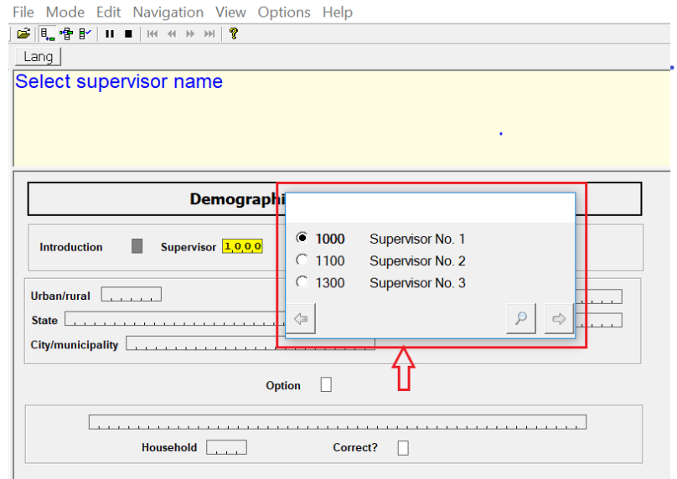

Once the supervisor is selected, the system requests to type/enter a cluster number. The reason to request the supervisor and the cluster number is because a few tasks carried out by the central office system are associated to specific clusters. For those taks the system needs the information that is coming from the specific “Supervisor Control” file described above in the summary table. Among other things, the supervisor control file keeps the number of households and individuals complete and incomplete collected in the cluster.

After entering the cluster number the system displays the geographical characteristics of the cluster; the cursor positions itself in the option field and requests from the Administrator to press the enter key. Once the enter key is pressed the menu with the options available for the central office is displayed as shown in the figure below.

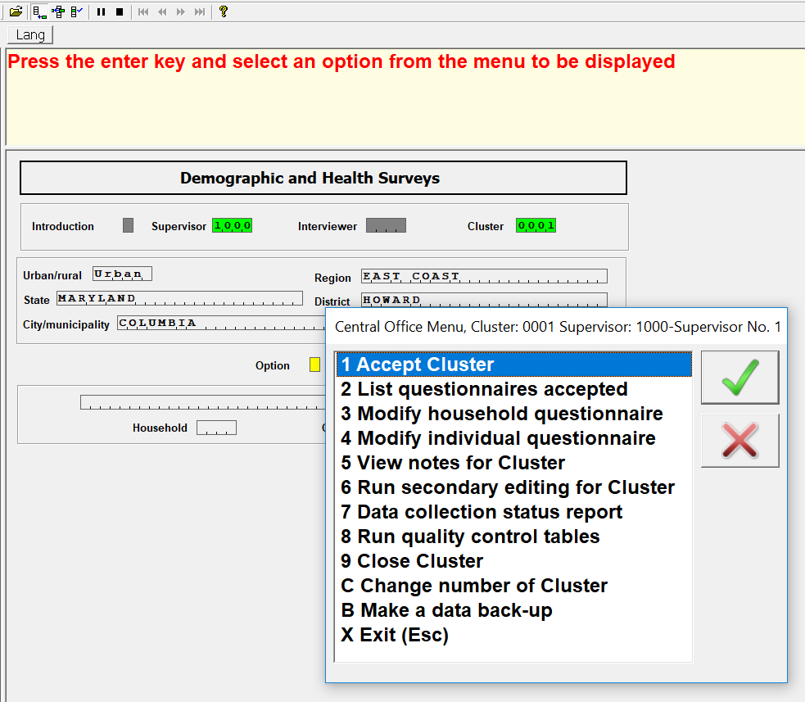

To select an option, the Administrator can type the first digit or character in the list of options or s/he can use the up and down arrow keys to highlight the desired option and press enter once the cursor is on top of that option. Let’s examine each one of these options.

# 4. Accepting cluster data coming from the field

As mentioned in section 2, all clusters listed under the second part of the report (“**Completed clusters to be accepted: 1-Arrived first time; 2-Already accepted; 3-Passed secondary editing**”), has to be accepted by the Administrator. Option 1 of the central office menu (“**1-Accept Cluster**”) is used for this purpose. As already described some of these clusters are new and actually this is for the most part the common way that clusters arrive to the central office. These type of clusters were sucessfully closed by the supervisors in the field and after beign closed were sent to the central office via IFSS or SyncCloud. Some other clusters may have already been accepted at the central office and even some may have already completed the data processing cycle. Essentially these late list of clusters were sucessfully accepted by the central office, but for some reason supervisors made modifications to the data in the field and the cluster was uploaded again. In a very few occacions, the Administrator may have already run secondary editing and even declared the cluster closed for no further action. For the latter, any action taken as part of secondary editing of the data is lost and secondary editing needs to be run again.

In any case option (“**1 Accept Cluster**”) has to be executed for each of these clusters. When accepting the cluster, make sure that the cluster and supervisor numbers are correct for the cluster to be accepted. Administrators may want to use option (“**7** **Data collection status report**”) to be described later to properly match clusters with supervisors.

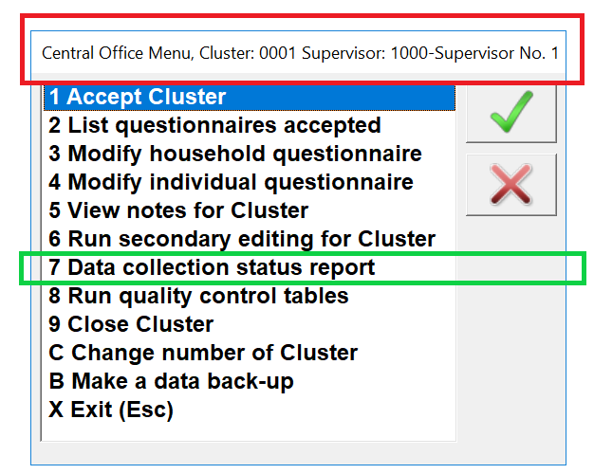

After selecting option 1, the central office runs an application to make sure that all rules to validate the data structure and completeness of information for the cluster are met. If no issues are identified by the application, the cluster is declared as accepted with the following message.

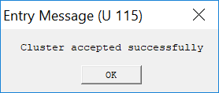

With a few differences, the controls carried out by the central office application are pretty much the same as those executed by the supervisor. Therefore, for the most part there should not be any problems and accepting the cluster is mainly used as a way of guaranteeing that the data did not get corrupted in the process of transmission from the field to the central office. After executing option 1, the central office displays an HTML report which has two parts:

The first part in itself has two components: the first component (circled in purple) is a report that lists all households collected in the cluster along with its individuals. It includes the result of the interview and the number of visits that were necessary to contact the households or the individuals. The second component of the report (circled in gold) is a summary of totals for households and individuals with complete and incomplete interviews.

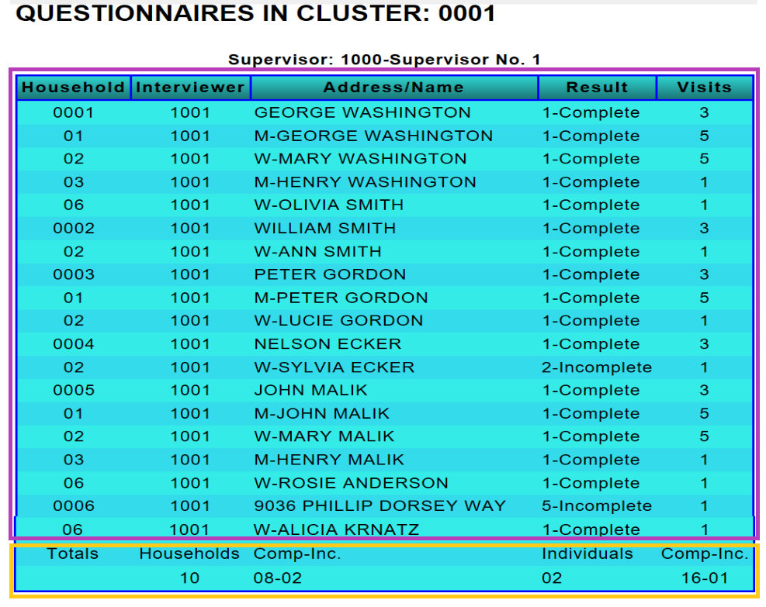

The second part is a summary of errors identified by the application as part of accepting the cluster. If there are no errors the report only has the first part and after dismissing the report the message informing that the cluster was successfully accepted is displayed. If there are errors the cluster cannot be accepted until all the outstanding issues are resolved. In that case, the central office system displays the following message.

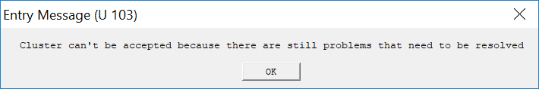

In this case a series of messages are appended to the first part of the report and they look like this:

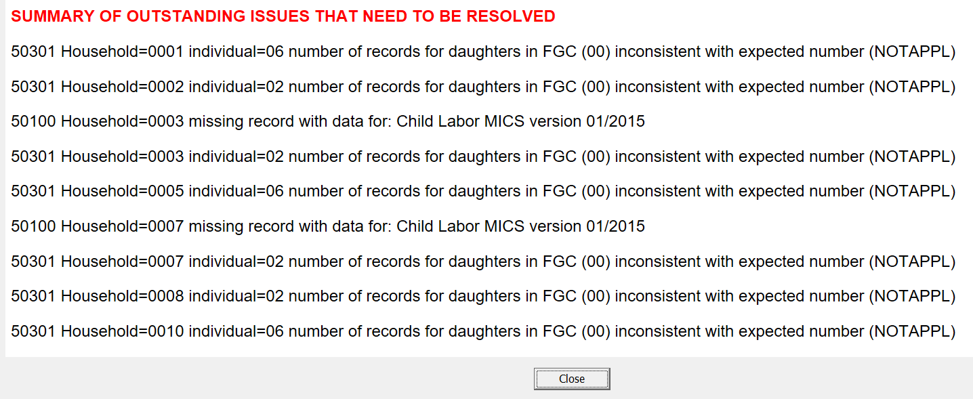

There are several ways to resolve the outstanding messages listed above:

* The first one is just by contacting the supervisor in the field and asking her/him to close the cluster again and to resend the data. This solution is necessary when the data was corrupted in the process of data transmission from the field
* The second one is to use options 3 or 4 from the main menu to fix any structural problem that may exist in the data as will be described further down
* It is also posible that the application still has some bugs and in that case the Administrator should contact the DHS data processing specialist assigned to the survey to fix the problem

The report is dismissed by pressing the close button in the report. The Administrator may also want to print and archive this report for documentation purposes. To print the report (used to print any HTML report by the system), right click anywhere in the report area and select the print option from the dropdown menu displayed.

As discussed in Section 2, if the cluster was previously accepted by the Administrator, the system displays the message:

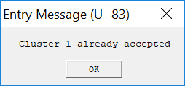

Upon dismissing the message with the  button, the Administrator is presented with a dialog to decide if s/he wants to override the existing cluster.

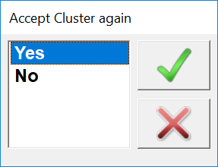

This happens with clusters that were already accepted by the Administrator as well as those that already passed secondary editing as described in section 2. If the cluster was just accepted by the Administrator, no work is lost by accepting the cluster again. However, if the cluster already passed secondary editing, that process needs to be repeated. Hopefully, secondary editing reports are archived with notes on the resolutions taken on them and that analysis can be used if the same messages are present again.

Once a cluster is accepted, the central office control database is updated to help keeping track of the cluster status.

# 5. Listing questionnaires for accepted clusters

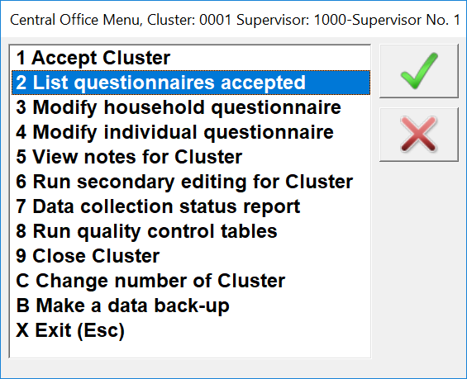

Option “**2 List questionnaires accepted**” is provided to assist in the production of a report to list the questionnaires that were already accepted for the active cluster. The option essentially produces the report described as the first part when accepting the cluster as described in section 4. The application that produces this report is the same used for option 1, but since the cluster was already accepted, it should not have any of the outstanding messages described as the second part of the report in section 4.

# 6. Modifying household and individual questionnaires for a cluster

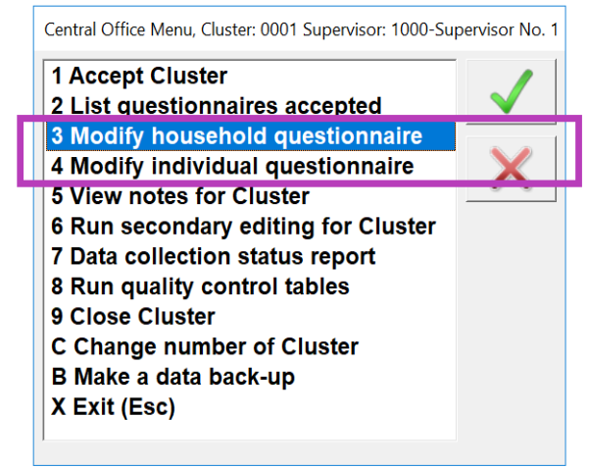

There are several reasons to include options “**3 Modify household questionnaire”** and **“4 Modify individual questionnaire**” in the central office menu as will be discussed in this section. Upon selecting one of these options, the system presents with the dialog below. The Administrator has to choose one of these options depending on the reason for selecting the option.

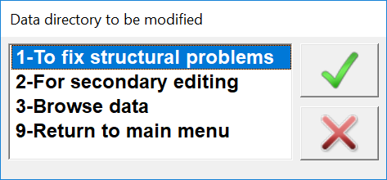

* 1-To fix strucural problems. This option is used to resolve structural problems. For the most part, these are cases that were displayed as part of the second component of the report published when the cluster was about to be accepted (as discussed in section 4). Normally, after fixing the structural problems it is necessary to accept the cluster again to make sure that the problem was resolved and in order to be able to accept the cluster. Essentially, any changes done as part of this process take place in files coming from the field and stored in directory \A**rrived**
* 2-For secondary editing. For the most part, this option is used to modify data as a result of the analysis of the secondary editing messages for the cluster. These types of modifications take place in the **\Closed** directory. Only clusters previously accepted by the Administrator can use this option. Normally, after making these types of modifications it is necessay to run secondary editing again to make sure that the problems intended to be resolved are no longer displayed
* 3-Browse data. This option is used to just browse through households or individuals that are part of the active cluster. Browsing data can only be done for clusters that were accepted. It is important to mention that if data is modified in the process of borwsing the data, those changes are included in the data file
* 9-Return to main menu. This self explanatory option returns to the main menu, with no other action taken.

When options 1 to 3 are selected from the previous dialog, the system performs a series of validations to make sure that the request is appropriate. For example, requesting to fix structural problems for a cluster that was already accepted. If that is the case, the system displays the message:

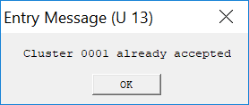

Upon dismissing the message with the OK button, the system presents the dialog:

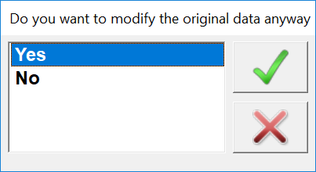

If option “Yes” is selected, the Administrator should go ahead and make the requested modifications, but since the cluster was already closed, it is necessary to accept it again.

There are some other errors where the request cannot be delivered. For example, if trying to browse or to fix problems related to secondary editing for a cluster that has not been accepted yet. In this case, a message like the one below will be displayed, and the system returns to the main menu upon dismissing the message with the OK button.

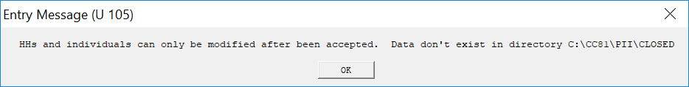

If all validations are successfully performed, the system displays a tree of cases for the cluster. The tree of cases corresponds to households or individuals depending on whether on the option selected (“**3 Modify household questionnaire”** and **“4 Modify individual questionnaire**”). The tree presented by the system looks as shown in the next figure.

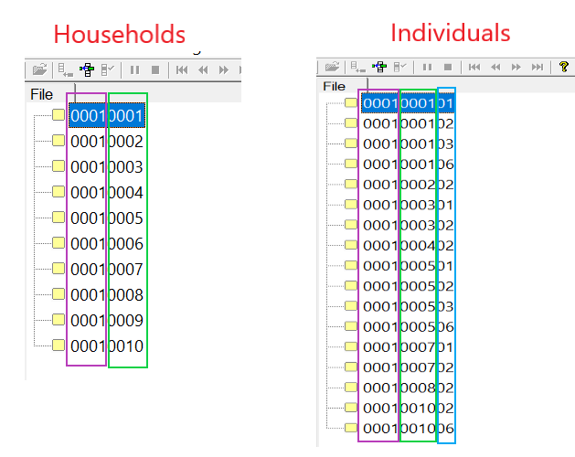

Households are identified by cluster (enclosed in purple) and household numbers (enclosed in green). Individuals are identified by the same fields plus the line number of the individual in the household roster or schedule (enclosed in turquoise). To select one of the households or individuals, just place the cursor over the desired case and double click on it. The Administrator can also use the up and down arrow keys to move over cases and press enter key once the highlighted case is the desired one. To navigate inside a case, sections 2, 4 and 5 of the “**CAPI Interviewer’s manual**” provides a lot of information on the different elements of CAPI screens and interface controls as well as of specific sections for the Household and Individual questionnaires.

# 7. Viewing notes taken at the time of the interview for the cluster

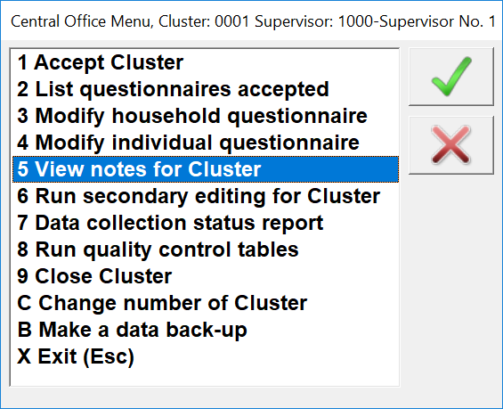

This option is used to browse through the notes recorded by interviewers at the time of data collection for all households and individuals. Notes can be useful when resolving messages at secondary editing time as they may have clues for unexpected interview scenarios. The option displays the following report:

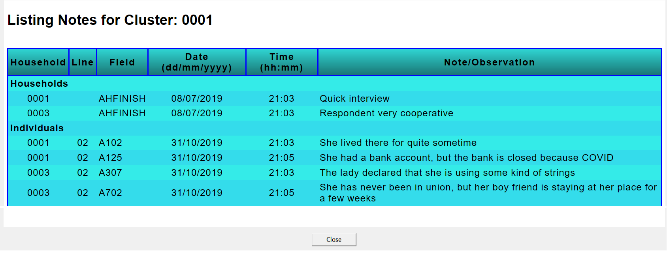

Some of the fields in the report are self-explanatory, but here is a definition of the headings:

* Household – This corresponds to the household number established at the time of generating the sampling of households to be visited in the cluster
* Line – For individual questionnaires, this column corresponds to the line number of the individual in the household roster. Note that for households this column is left blank
* Field – This is the question number where the note was taken when the data was being collected. Questions can start with AH, A, and/or AM. AH corresponds to question numbers in the household questionnaire, A corresponds to question numbers in the women questionnaire, and AM to question numbers in the male questionnaire. This report was produced using the standard DHS applications and for that reason questions start with A. Nevertheless, for actual country surveys the A’s at the beginning of the question numbers are replaced by a Q. Some fields do not have a question number because they are not associated to a question number in the questionnaire. In that case the DHS DP specialist gives them some mnemonic names. For example, questionnaires cover page questions don’t have numbers and, as a result, they use names like: ACLUSTER, ALINE, ASTATE, and so on.
* Date & Time – They correspond to the date and time when the note was taken by the interviewer
* Note/Observation – This is the actual text of the note as typed by interviewer

# 8. Running secondary editing applications for the cluster

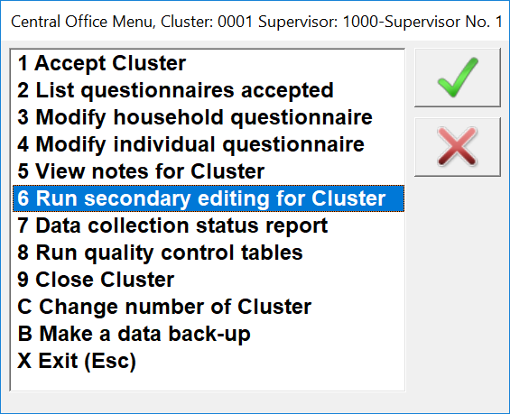

Secondary editing is a critical step in processing a survey because it eliminates inconsistencies that may be left after data have been collected. Secondary editing can be run at any time after a cluster has been previously accepted by the administrator. The CAPI data collection applications can be designed in such a way that they will be able to identify any inconsistency at the time of data capturing. Nevertheless, to avoid interrupting the flow of the interview and because some inconsistencies require an in-depth analysis and the attention of subject-matter specialists or senior staff to properly resolve them, they are not identified at data collection time. As a result, the DHS program prefers to implement these checks after data capturing with a couple of secondary editing applications that run as part of the central office system. The result of executing option “**6 Run secondary editing for cluster**” is an output reporting the inconsistencies identified for the cluster. The report should be printed and passed to office editors previously selected. It is recommended that office editors participate in the survey pretest and main training as that gives them insight on the objectives and the topics that are covered by the survey. Office editors analyze the messages and decide whether data needs to be changed or not. Secondary editors will use the “**Secondary Editing Guidelines”** manual to properly resolve the inconsistencies identified by the applications. The manual is customized for the survey and it will be provided by the DHS data processing specialist. A typical error message is displayed as shown in the figure.

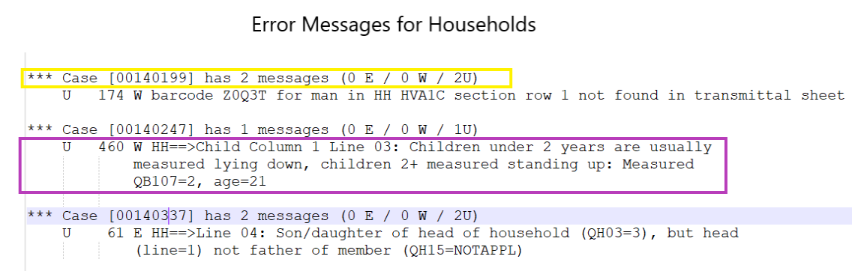

There are two secondary editing applications, one to check inconsistencies for households and the other for individuals. When executing option “**6 Run secondary editing for cluster**” both applications run for the active cluster. The figure above is for messages displayed for households. Error messages are made of two parts:

* The first part (enclosed in yellow) corresponds to the identification of the case where the inconsistency occurs. Enclosed in square brackets is the actual case identification. The first four digits correspond to the cluster number and the following four to the household number. This specific case is for Cluster 0014 and household 0199
* The second part (enclosed in purple) correspond to the error message number. The “**U**” is a letter used by CSPro to inform that this is a user error. After the **U** is the actual error number which in this case is 460. The error number is followed by a text summary that describes the inconsistency. As mentioned earlier, office editors should use the secondary editing guidelines document to resolve the inconsistency. Error numbers are described in that document and they are presented by order. Sometimes the message has the exact question number that relates to the error, but some others office editors should be familiar with the questionnaire to know where to locate the source of the error

The report produced for individuals is pretty much the same as that of households. The only difference is that there are two extra digits as part of the identification following the household number. These two digits correspond to the line number of the individual in the household schedule.

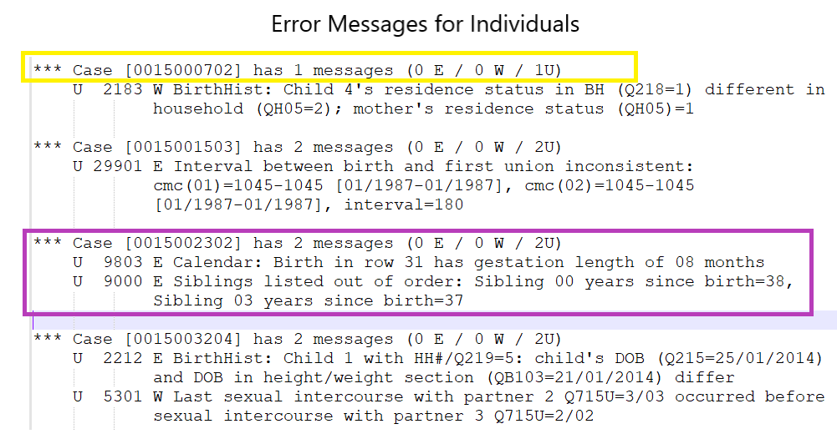

For individuals as well as for households, there may be one or more error messages reported for a case. For example, for cluster 0015 household 0023 and individual line number 02, there are messages 9803 and 9000 reported.

To fix the problems reported by applications, office editors either write the solution in front of the messages in the paper report or they are given access to the cluster data files to fix those errors. To help with this task, office editors should get familiar with the naming conventions given to the CAPI system for questions (fields, variables) as described in the Section 6 on how to view notes. The naming conventions in that section are described when defining the column for “**Field**”. To implement the changes, the Administrator or office editors use options 3 or 4 depending on whether the modification is for households or individuals. Changes are normally done by the Administrator when office editors write on the paper report the changes or they can be done by office editors themselves when they are provided with access to the central office system.

# 9. Producing a data collection status report for all clusters

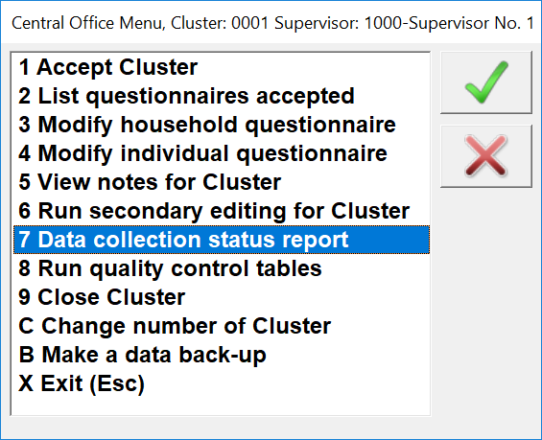

Option “**7 Data collection status report**”, is used by the central office system to produce a report that help the Administrator to know the status of every cluster. It is also a tool for the survey management team to get an idea of the general status of the fieldwork operation. After selecting option 7, a report like the one below is produced.

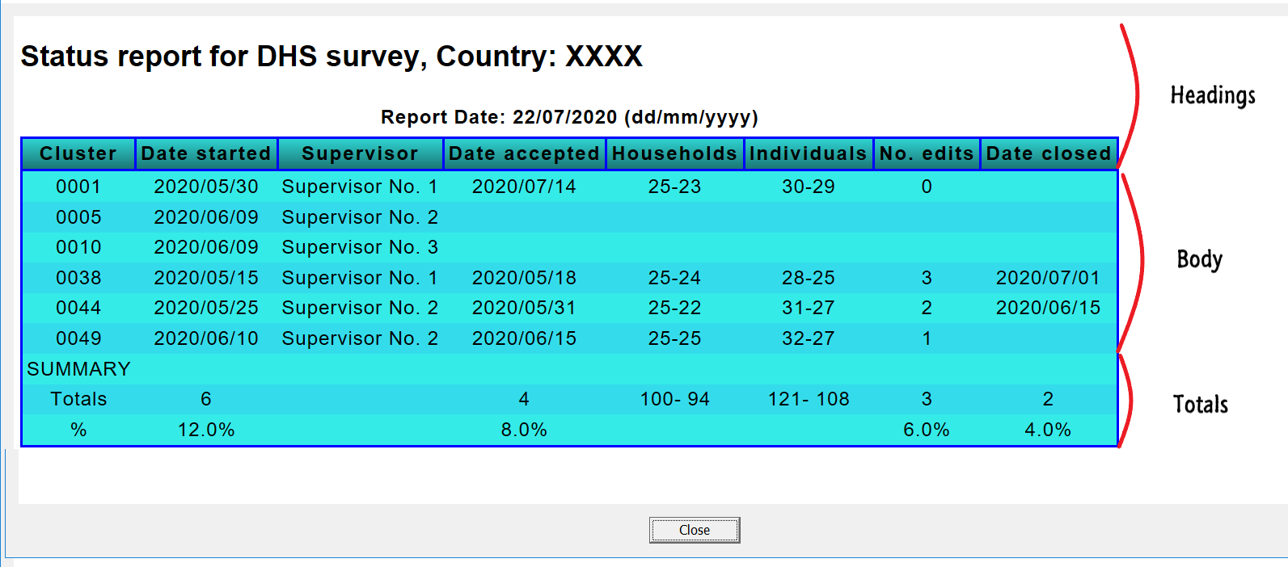

The report displays the status for each cluster for which some activity that triggered the action of sending data to the central office, occurred in the field. For example, in this report data for 6 clusters have already started some activity in the field. Clusters not listed in report mean that nothing has happened to them. For purposes of this document we are using a survey where 50 clusters are expected for the survey. The report consists of three parts: The headings, the body, and a summary of totals.

* The headings are just the report title and a description of each column displayed. The columns included in the report are:
  + **Cluster**, corresponds to the survey cluster number
  + **Date started**, corresponds to the date when interviewers opened for the first time a household in the cluster. Every time a supervisor in the field accesses the CAPI system and if they are connected to the internet, data that has been sent by interviewers to supervisors are automatically sent to the central office. The system uses this data to get the date when the data collection for the cluster started
  + **Supervisor**, is the name of the supervisor responsible for the cluster. There is the possibility that a cluster was started by mistake by a supervisor. This problem will eventually be resolved as the correct supervisor is changed when the cluster is accepted at the central office
  + **Date accepted**, this column corresponds to the date when the cluster was accepted by the central office. As described in Section 2, all clusters listed under the second part of the report must be accepted by the Administrator. In order to accept a cluster, it is necessary to know the supervisor responsible for the cluster. If the Administrator does not know the supervisor, s/he can execute this option to know the name
  + **Households,** this column has two numbers: The first one corresponds to the number of households visited in the cluster; and the second one corresponds to households successfully interviewed (code 1 as result of the household interview). The total number of households is normally a constant unless special circumstances occur for the cluster. In some surveys the number of clusters to be collected for urban clusters is different than for rural clusters
  + **Individuals,** this column is essentially the same as that of households, except that it refers to individual questionnaires. Contrary to households, the number of individual interviews is defined by the number of eligible individuals identified by the household roster
  + **No. edits,** this column essentially reports the number of times the secondary editing applications have been run for the cluster
  + **Date closed,** this column gives the date when the administrator declared the cluster as closed. Generally, the administrator declares the cluster as closed when office editors decide that there is no need for more corrections based on the secondary editing report. If no messages are found by the secondary editing applications, the Administrator can declare the cluster closed
* The body of the report essentially indicates the status of the cluster. The status in general reflects the chronological order of events that a cluster goes through. Consequently, it is important to note that as the process of clusters proceeds, the fields in the report are populated from left to right. It is also worth noting that the format for dates in the body of the report are (YYYY/MM/DD). The following considerations are important to highlight for this portion of the report.
  + If the cluster is not listed, it means that no activity has been taken in the field for that cluster
  + When only columns for: Cluster, Date started and Supervisor have information and the remaining columns are left blank, it indicates that fieldwork for the cluster started and it is still ongoing. This is the minimum of information required for the cluster to be included in the report. Clusters 0005 and 0010 in our example are in that category
  + Once a cluster is accepted by the Administrator, columns for Date accepted, Number of Households total and complete and number of Individuals total and complete are populated by the system. At that point zero is assigned to the number of edits
  + As soon as a cluster is accepted, secondary editing applications for the cluster can be run. For example, in our report clusters 0001 and 0049 were accepted, but cluster 0001 has not gone through secondary editing, yet. For that reason, the number of edits for cluster 0001 is 0 (zero) whereas for cluster 0049 is 1
  + Finally, the ultimate objective for every cluster is to populate the column “Date closed”. The reason is because the presence of information in that column indicates that cluster has gone through all the process and that a decision was made to declare the cluster closed. Clusters 0038 and 0044 in our example were declared closed. Note that it was necessary to run 3 times the secondary editing applications for cluster 0038 whereas for cluster 0044 it was only necessary to run them 2 times. It is very likely that secondary editing messages are currently being analyzed for cluster 0049
* The third part of the report is a summary of totals. This portion gives a clear idea of the status of the fieldwork operation. It could be very useful for the survey management team as it indicates the work accomplished or to be completed for different tasks for the cluster. The summary has two elements: Totals and Percentages
  + Totals are essentially the number of clusters that have passed each of the process stages. For columns households and Individuals, it gives the total number of cases visited followed by the number of successful interviews carried out
  + Percentages gives a clear idea of the general status of the survey as it provides percentages for the major stages of the survey operation. It gives the percentages of clusters that already started fieldwork; percentage of those that were accepted at the central office; percentage of clusters with at least one run of secondary editing; and the percentage of clusters closed

The report can be produced sorted by cluster number or by supervisor code. Upon selecting option 7, the central office system displays a dialog so that the Administrator decides how the report will be produced. Most of the times the report is produced by cluster number but having it by supervisor is also useful as it can be used to get an idea of supervisor’s workload and efficiency.

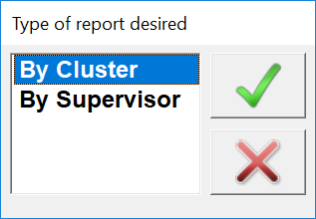

Finally, as with any other HTML report, the report window is dismissed with the close button.

# 11. Closing a cluster

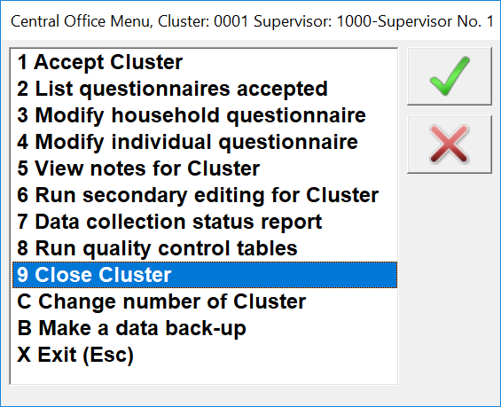

All clusters eventually must be closed. As mentioned earlier at some point after analyzing the report of the secondary editing applications, a decision has to be made if corrections are necessary or if the cluster can be closed. This decision is made by office editors when they determine that the remaining messages do not need corrections. The decision can also be made by the Administrator if no errors are reported by the secondary editing applications. In either case, the Administrator should use option “**9 Close Cluster**” for this action to take place. To close a cluster, it is mandatory for the cluster to be first accepted by the central office. It is also necessary to run the secondary editing applications at least one time for the cluster. This is the end of the process for the cluster. The status report will reflect this action by displaying in the column “Date closed” of the status report the date when the cluster was closed, as was defined in Section 9.

# 12. Moving among clusters

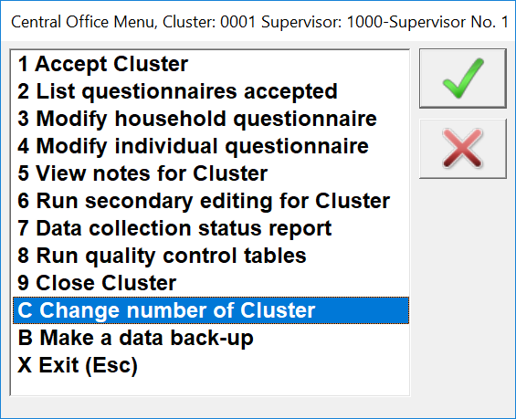

As can be observed throughout this document, most of the options used by the central office system are associated to a cluster. Only options 7, 8, B (to be described later) and of course this option C, are run for the entire survey and therefore they are not cluster dependent. For all other options, the Administrator needs to be aware of the cluster s/he is working with. This option is used frequently as the Administrator moves continuously across clusters. If a cluster is to be accepted (option 1) or if the questionnaires for the cluster have to be listed (option 2), it is important to have the correct supervisor number responsible for the cluster. For other options having the correct supervisor assigned to the cluster is not necessary. As mentioned earlier, the supervisor name can be obtained from the status report as described in Section 9.

# 13. Backing-up the data

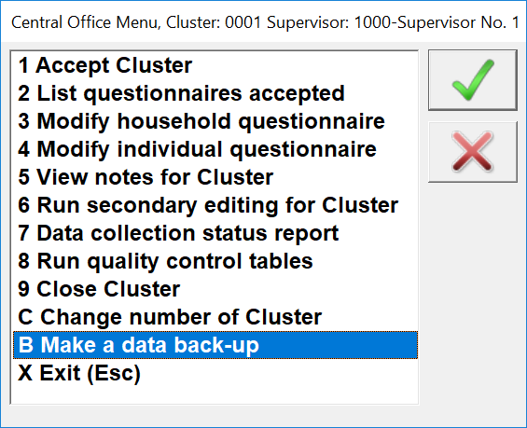

Making a back-up is very important to safeguard the data arrived and being processed at the central office. It is recommended to execute this operation (on a daily basis) at the end of each day, especially when significant activity occurred with the system. The central office system, back-ups data from directories \**Arrived** and \**Closed**. The data are backed up to flash memory devices and to properly back them up it is necessary to create folders \**Arrived** and \**Closed** in the root of the flash memory designated for that purpose. Each one of those folders are backed-up with a round robin algorithm that keeps the latest 9 back-up operations executed by the Administrator. The back-up is done for all data files available in those folders in a compressed ZIP file format. The first time a back-up is made, the central office system gives the name “**ARRIVED_0.zip**” for all files in \**Arrived** directory. The second time it will give the name “**ARRIVED_1.zip**”, and so forth. When reaching “**ARRIVED_9.zip**”, the system resets itself and start again with 0 maintaining the previous 8 back-up versions. The date of the ZIP file can be used to know the latest version of the back-up. It can also be determined by checking the latest back-up number without interruption. The same approach is used for directory \**Closed.**

When this option is executed the system checks if a flash memory with directory \**Arrived** is inserted into a USB port. The system displays the message below if either the flash memory is not inserted or if directory \**Arrived** is not present in the device.

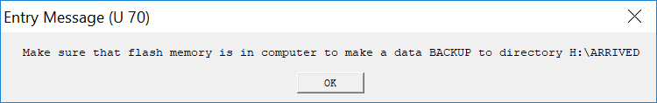

After dismissing the message with the  button, If the flash memory is not yet connected it displays the following message and the operation is cancelled. The same steps take place to back-up directory \**Closed**.

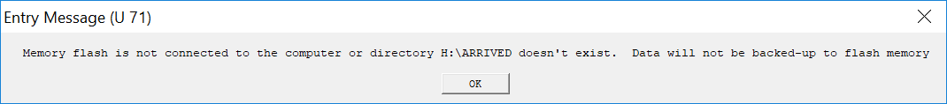

If all goes all right after the back-up is completed, a message is displayed to acknowledge the success of the back-up operation of the \**Arrived** directory. The same kind of message is repeated for the \**Closed** directory.

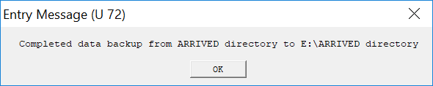

# 14. Exit (Esc)

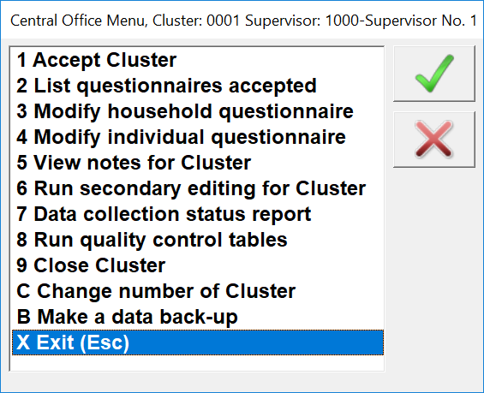

It is important to properly exit the central office system. This can be done with option “**X Exit (Esc)**”. This option can also be accomplished by simply pressing the Esc (Escape) key while the menu is on focus. It is recommended to exit the system if the Administrator is not going to be in the office where the desktop with the central office installed is located. This is as a precaution to avoid inadvertently misuse of the system by people not familiar with it. The system remembers the latest Supervisor and Cluster numbers that were used and, as a result, getting back into the system is just a matter of launching the system and hitting the enter key a couple of times.